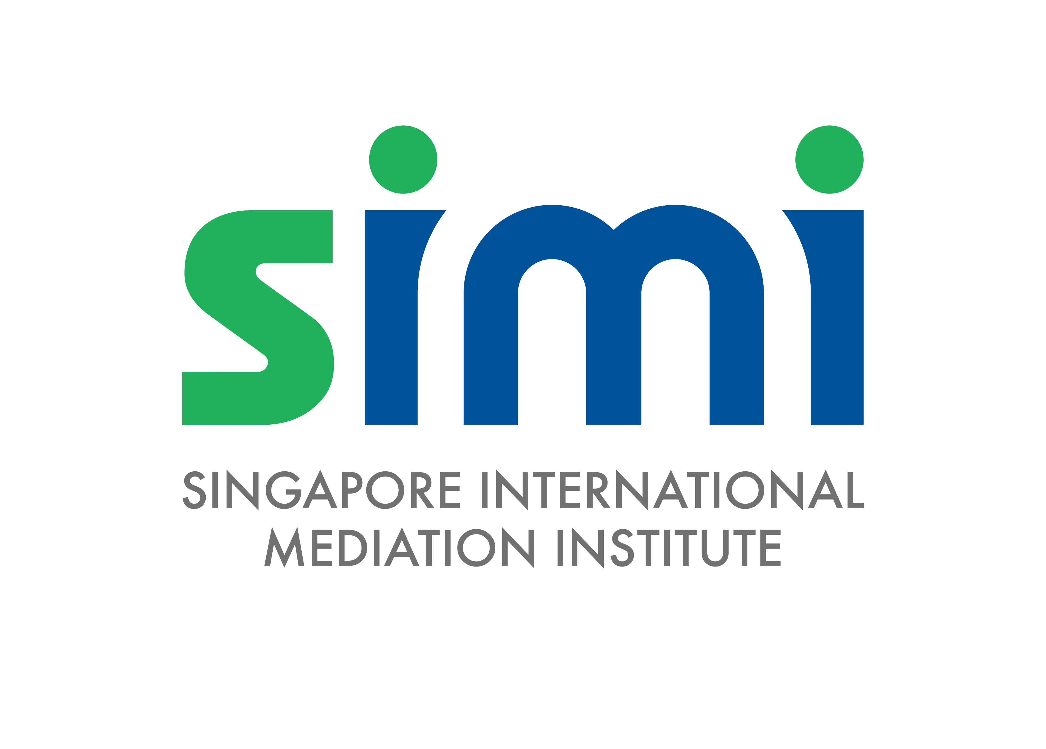

Singapore International Mediation Institute (SIMI)

Private Mediation Verification (PMV)

Application Form

Version (Nov 2024)

Table of Contents

A. About the SIMI PMV APPLICATION PROCESS 3
1. Eligibility & Scope Of SIMI PMV 3
2. Application Process 3
3. Application Results 3
4. SIMI PMV Fees 4
B. Application Form (SIMI PMV) 5
1. SIMI Mediator Details 5
2. Case Experience Details 6
3. Feedback Request Form 7

About the SIMI PMV APPLICATION PROCESS

Eligibility & Scope of SIMI PMV

  - The SIMI PMV scheme is designed for existing SIMI Mediators who wish to submit their application to become SIMI Accredited Mediator Level 2 or 3 directly to SIMI.

Application Process
  - Applicants are to complete all sections stated on the application form (Part B of this document) and send the completed form together with any supporting documents to admin@simi.org.sg with the subject as “SIMI PMV APPLICATION”.
  - The review process is expected to take between six (6) and eight (8) weeks, subject to any further clarifications or to furnish additional documents. Applicants are to ensure that the email address provided on the Application Form is active and checked regularly for all correspondence from SIMI relating to the application.

  - SIMI welcomes applications throughout the year.

Application Results

  - Application results will be sent by email.

  - In the case of a successful result, the Applicant will be granted their new SIMI Mediator status, subject to the payment of any applicable fees (see Section 4).

  - In the case of an unsuccessful result, the applicant may make a re-submission or new submission after a waiting period of three (3) weeks.

SIMI PMV Fees

  - The fees payable for the SIMI PMV scheme are set out below.

S/N | FEE DESCRIPTION | AMOUNT (SGD)
 | Application Fee for Consideration As SIMI Accredited Mediator Level 2  This is an administrative fee that is charged for reviewing each application. | 500.00
 | Application Fee for Consideration As SIMI Accredited Mediator Level 3  This is an administrative fee that is charged for reviewing each application. | 800.00

  - Payment can be made by the following methods.

    - PayNow to UEN No. 201420752C (for individuals/businesses which have an account with a participating bank in Singapore).
    - PayPal via https://www.paypal.com/paypalme/thesimichat

    - Payment by electronic fund transfer is to be made to the following bank account. Please send us an email at admin@simi.org.sg with proof of payment after you have successfully made the transfer:

Account Name: Singapore International Mediation Institute Limited CitiBank Account: 0-860317-001
Currency: SGD

Bank Name: Citibank, N.A. Singapore
Bank Address: 3 Changi Business Park Crescent, 07-00, Singapore 486026

SWIFT Code: CITISGSG

Bank Code: 7214
Branch Code: 001

For overseas transfers, please quote 'OUR' and take note that you will bear all transaction fees. Please request your bank (as necessary) to charge such fees to you, so that SIMI receives the full amount invoiced. These fees include the charges levied by the sending bank and any charges applied by intermediary (correspondent) banks.

Application Form (SIMI PMV)

SIMI Mediator Details

1.1 Name Of SIMI Mediator (Applicant)

Click here to enter text.

1.2 Email Registered With SIMI

Click here to enter text.

1.3 Contact Email (If different from 1.2)

Click here to enter text.

1.4 Contact Number

Click here to enter text.

1.5 Profession

Click here to enter text.

1.6 Nationality

Click here to enter text.

1.7 Country you reside in

Click here to enter text.

Case Experience Details

Please indicate by checking the boxes below whether you will be relying on case numbers or mediation hours in satisfying the requirement case experience.

You may wish to refer to the “SIMI Guidelines For The Determination Of Full-Scale Mediations” (available for download on SIMI’s website) for guidance on whether your cases qualify for the case number requirement.

☐ | CASE NUMBER  5 full-scale cases for SIMI Level 2  12 full-scale cases for SIMI Level 3
☐ | MEDIATION HOURS  (if one or more mediations lasts longer than a day)  50 hours for SIMI Level 2  120 hours for SIMI Level 3

Please provide information for the cases you will be relying on to satisfy the case experience requirement. Do ensure that the information provided matches either the case number of mediation hour requirement that you have indicated above.

S/N | Date | Venue | Type of dispute (e.g. contract, partnership, shareholders, property, etc) | Duration  (hours) | Was the mediation administered by a Mediation Service Provider (MSP)  (If so, to state name of the MSP): | Outcome of mediation (i.e. was the dispute  resolved?) *If the dispute was only resolved in part, please state accordingly | Contact Information (Parties or  Counsel)2

Feedback Request Form

Please attach completed Feedback Request Forms when submitting this application.

Ideally, you should collect at least 2 forms per mediation (i.e. 1 from each party, or 4 if you are collecting 1 form from each party and their counsel).

For applications to be SIMI Accredited Mediator Level 2, you will need to submit feedback request forms from at least 2 mediation cases listed in Section 2.

For applications to be SIMI Accredited Mediator Level 3, you will need to submit feedback request forms from at least 5 mediation cases listed in Section 2.

Feedback Request Forms are available for download on SIMI’s website. Alternatively, an online version is also available on our website and you may ask your parties to visit “http://www.simi.org.sg/Mediator-Feedback” and submit their feedback there.

By submitting this application form, I hereby declare that all information provided are true and accurate to the best of my knowledge, and that I have sought the consent of the parties, counsel or mediation service provider to disclose their personal data to SIMI for the purposes of processing this application. I undertake to inform SIMI as soon as reasonably possible should I be aware that any of the information previously provided on this application form is no longer true. I understand and accept that SIMI has the right to reject or revoke an application should any information provided on this form be found to be untrue. I consent to SIMI using my personal data provided on this form to contact me for the purposes of processing this application.
Click here to enter text. |  | Click here to enter text.
Name and Signature |  | Date

Please ensure that this is an email address that is active and checked regularly as all correspondence relating to the application will be sent to this email.

